 | Eye Contacts & How They Work
Explaining eye Contacts  Eye contacts are important optic devices that many people are using for vision correction. The contacts are worn directly on the eye cornea. However, some people choose them for cosmetic purposes.  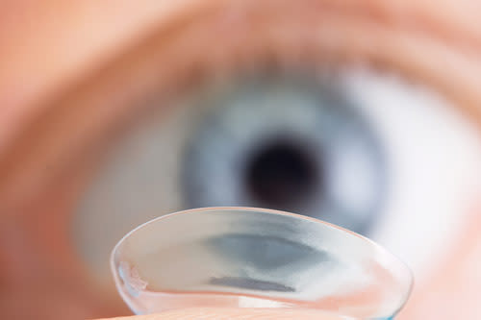  How Eye Contacts Work  - Eye contacts help people with poor eyesight to refocus the incoming rays of light on the retina of the eye to bring clear vision. | Contact lenses achieve clear vision by increasing or decreasing the Cornea’s focus potential, thus projecting light into eye’s retina and help to treat refractive errors.  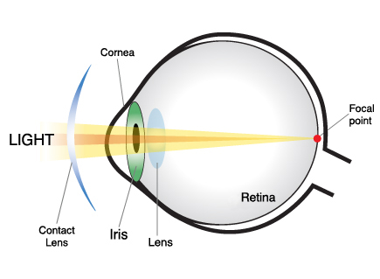  - With eye contact lenses, problems associated with refraction of light such as myopia, astigmatism, presbyopia and hyperopia are corrected.  - For Myopia, the lenses correct refraction by raising the focal length of the light entering the eye. Concave lenses are used and they deviate light reaching the eye from distant objects. This light is then combined by cornea and the eye lenses thus producing a clear image. | - In Hyperopia, convex lenses are used in eye contacts. The converging lenses reduce the focal length of the right reaching the eye, thus reducing the image’s distance. They then combine the light rays before they reach the eyes. The eye lenses then deviate the converged light. The combined deviation of light by the eye lenses and contact lenses enables better focus of nearby objects into the eye retina.  - In Astigmatism, the victim’s has an abnormal shape of cornea, which causes divergenc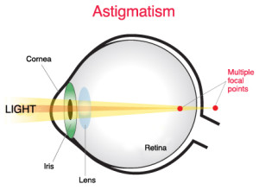e of light from different vocal points of eye’s retina. Special lenses known as toric lenses are used to correct the problem. The lenses establish various focusing potentials in horizontal and vertical directions. They also have different focal lengths and has an optical power formed at right angle against each other, which corrects the multiple focal points attained on the eye’s retina.

Analyzing a Solar Oven Technology

How Solar Oven Works
- Sunlight is not hot on itself and we feel its warmth when the light rays from the sun hit molecules on our skin. This is the concept that is used in making solar cookers and solar ovens.
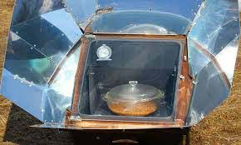
- Solar ovens work by converting sunlight into heat. This conversion takes place when light particles or photons moving within waves of light interact with molecules moving within a subject. Sunlight produces electromagnetic light rays that have very high levels of energy. When the rays hit matter, the molecules in the matter start to vibrate. This vibration leads to production of heat. Solar ovens apply different methods to collect this heat.
- Solar ovens utilize metal reflectors positioned around an oven to collect the maximum amount of light. The photons pass through a transparent glass of the oven’s top, striking the inner side of the insulated box.
- Best results are achieved when a dark metal pot is placed at the center of the oven to absorb the incoming light molecules.
- Solar ovens utilize metal reflectors positioned around an oven to collect the maximum amount of light. The photons pass through a transparent glass of the oven’s top, striking the inner side of the insulated box.
- Best results are achieved when a dark metal pot is placed at the center of the oven to absorb the incoming light molecules.
- The cooking pot then becomes hotter than the surrounding air causing the heat to attempt escaping to cooler spaces. Since light cannot leave through the glass top, it remains trapped inside. Heat is reflected back to the metal pot causing the temperature of the pot to rise dramatically to over four hundred degrees Fahrenheit.
- 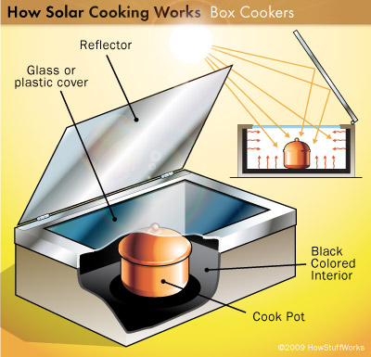
Impacts on the society
- Solar have changed many lives in the society since they provide a cheap source of energy to many households. They also promote healthier lifestyles for they cook healthier foods. Solar ovens are very friendly to the environment and do not cause any type of pollution or dirtying the surroundings. Furthermore, sunlight is a free gift of the nature. Solar ovens are easy to use and can be carried around.
- The future of this technology is very promising. That is because the technology is growing further and new applications to solar energy continue to come up.
References
Lapidot-Lefler, N., & Barak, A. (2012). Effects of anonymity, invisibility, and lack of eye-contact on toxic online disinhibition. Computers in human behavior, 28(2), 434-443.
Folaranmi, J. (2013). Performance evaluation of a double-glazed box-type solar oven with reflector. Journal of Renewable Energy, 2013.
Vijayavenkataraman, S., Iniyan, S., & Goic, R. (2012). A review of solar drying technologies. Renewable and sustainable energy reviews, 16(5), 2652-2670.

